**A PROPOSED OFFERING OF PAYROLL**

**SYSTEM FOR WILLTOP HARDWARE AND ELECTRICAL SUPPLIES**

A Project Proposal Presented to the

Faculty of Datamex College of Saint Adeline, Inc.

In Partial Fulfillment of the Requirements for the

Degree of Bachelor of Science in Information Technology

**Prepared By:**

Ablola, Carlo

Bernadez, Brian R.

September 2025

**PROJECT PROPOSAL**

**INTRODUCTION**

This chapter explains the proposed project, which is a Payroll System for WILLTOP Hardware and Electrical Supplies.

The proposed project is a Payroll System for WILLTOP Hardware and Electrical Supplies. It will be built using Visual Basic 2010 (VB10). This system will help the Store owner manage employee attendance records, calculate salaries based on days worked, handle government deductions, and create payslips.

This project focuses on developing a payroll system for your hardware store. It will improve how you manage and process salaries. Doing payroll by hand can take a lot of time and lead to mistakes, especially with many employees. This system aims to make salary calculation faster, easier, and more precise. It will keep records of employees, including their names, positions, salary rates, and work schedules. It will also monitor the attendance and calculate salaries based on days worked, overtime, rest days, and holidays.

The payroll system will manage deductions like contributions to SSS, PhilHealth, and PAG-IBIG. This removes the need for manual calculations, reducing the chances of errors. At the end of each pay period, the system will generate payslips that show a clear breakdown of each employee's earnings, deductions, and the total amount they will receive. This makes the process more transparent for employees and easier for the employer.

Implementing this payroll system will help your hardware store to be more organized and efficient in handling payroll. It will lower errors, save time, and ensure that all government requirements, like contributions, are calculated and recorded correctly. Overall, this system will improve your business operations and ensure your employees are paid accurately and on time.

**OBJECTIVES OF THE PROJECT**

* To develop a payroll system that will help the hardware store compute employee salaries faster and more accurately.
* To store and manage employee information such as name, position, salary rate, and attendance records.
* To compute salaries including overtime, holiday pay, and rest day work.
* To include deductions such as SSS, PhilHealth, and Pag-IBIG contributions.
* To generate payslips that show detailed breakdowns of salary, deductions, and gross pay.
* To reduce human errors in salary computations and avoid delays in employee payments.
* To help the company save time and become more organized in handling payroll tasks.
* To make it easier for the business to comply with government payroll requirements and reports.

**GOALS OF THE PROJECT**

* To provide an efficient and reliable payroll system for the hardware store.
* To improve the way employee salaries and records are managed.
* To make payroll processing faster, easier, and more accurate.
* To ensure that all employees are paid correctly and on time.
* To support the company in becoming more professional and organized in their business operations.

**CLIENT INFORMATION**

The client of the proposed project is WILLTOP Hardware and Electrical Supplies, which will be the main user of the Payroll System.

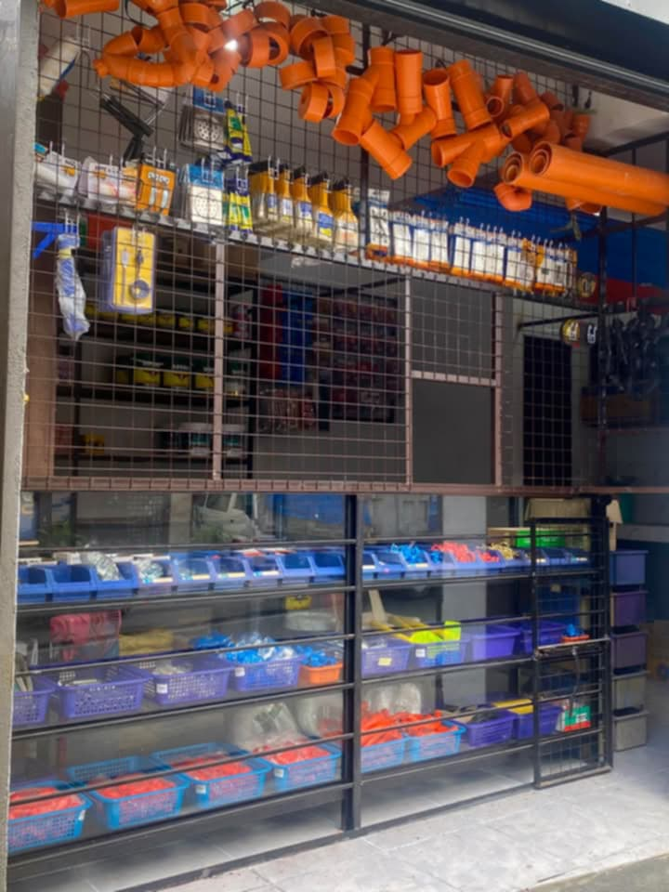**Name of the client organization:** WILLTOP Hardware and Electrical Supplies  
**Address:** Mac Arthur Highway, Dalandanan, Valenzuela City  
**Owner:** Leonora Reyes Tan  
**Contact information:** 09995447637

*Image 1. WILLTOP Hardware and Electrical Supplies*

**Brief description of the client’s business and industry**

WILLTOP Hardware and Electrical Supplies is a company that provides construction hardware and electrical materials to residential and commercial clients. The company employs several workers whose attendance and salary computation are essential to daily operations.

**PROJECT SCOPE**

The proposed project covers the development of a desktop-based Payroll System using Visual Basic 2010.

**Features**

* Employee’s informations (names, positions, and salary rates)
* Attendance record module (monitoring of days worked, overtime, rest days, holidays)
* Payslips are generated and printed per employee with detailed breakdown of earnings and deductions.
* Payroll summary reports (printable and digital format)
* Option to view and print attendance records.
* Salary computation based on attendance and rates.

**Including these deductions**

* SSS
* PhilHealth
* Pag-IBIG

**Inclusions**

* System development using VB10.
* Database integration (SSMS)
* User interface design and testing.
* User training for Admin.

**Exclusions**

* Long-term system maintenance.

**Assumption and constrains**

* Users: Only Admin (Store owner) will have access to the system.
* Attendance must be accurately encoded to ensure correct salary computation.
* The system is designed for Windows desktop environment only.

**PROJECT APPROACH**

This project will follow the Agile **methodology**, which ensures a step-by-step development process from planning to deployment. This methodology is suitable for this project because requirements are clear and stable.

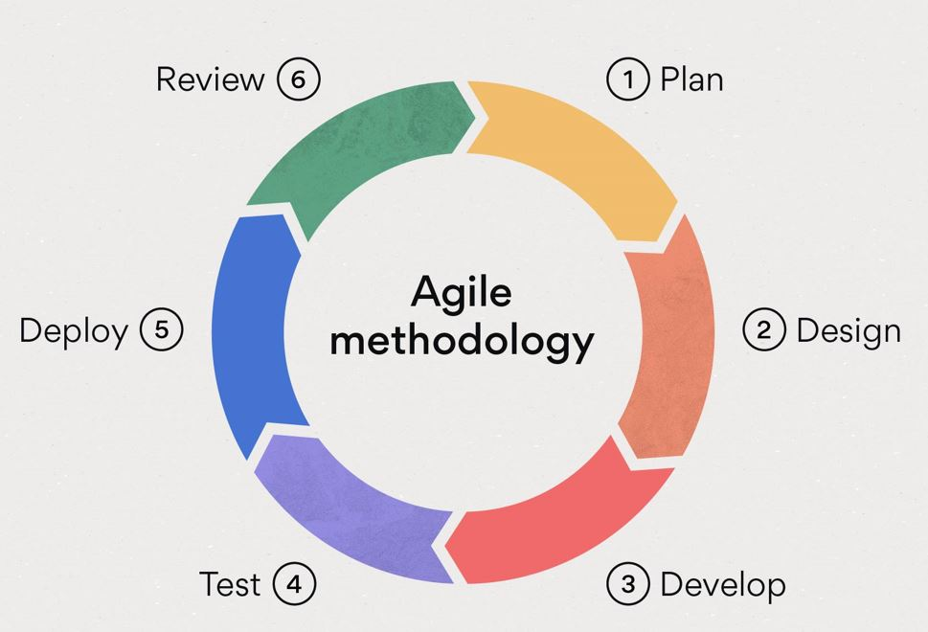  
  
  
  
  
  
  
  
  
  
  
  
 *Image 2. Agile Methodology*

**Plan**

In this phase, the project requirements were identified. The payroll system must include:

* Employee information’s (names, positions, and salary rates).
* Attendance monitoring with calendar-based in/out and manual encoding.
* Salary computation with deductions (SSS, PhilHealth, and Pag-IBIG).
* Payslips will generate and printed.
* Payroll summary and attendance reports.

These requirements were broken down into manageable sprints, starting with the Dashboard, followed by Attendance, Payslips, and Reports.

**Design**

The system design was created, including:

* Database structure for Employees, Attendance, Payroll, and Deductions.
* User interface mockups for the Dashboard, Attendance Calendar, and Payslip forms.
* Workflow design based on the flowchart (Dashboard → Select Employee → View Attendance / View Payslip → Reports).

**Develop**

During this stage, coding of the payroll system modules was performed.

* The Dashboard was implemented with Add Employee and Employee List (DataGrid).
* The Attendance module was built, allowing in/out logging, overtime, rest days, holidays, and manual updates.
* The Payslip module was developed to automatically compute gross pay, apply deductions (SSS, PhilHealth, and Pag-IBIG) and generate the net pay.
* Reports were created for payroll summaries and attendance logs.

**Test**

Each module was tested to ensure accuracy and reliability:

* Employee information is correctly saved and displayed in the DataGrid.
* Attendance calendar properly reflects workdays, overtime, and holidays.
* Salary computations match expected results, with correct deductions applied.
* Payslip details are accurate and printable.

**Deploy**

The tested system was deployed for use in the office. Store owner can now:

* Add and manage employee records.
* Encode attendance data.
* Generate payslips automatically.
* Print payroll summaries and reports for management.

**Review**

User feedback was collected after deployment for example:

* Owner can suggest adding late penalties.
* Based on feedback, the cycle returns to Plan, ensuring the system evolves and improves with each sprint.

**PROJECT TEAM**

The proposed payroll system will be developed by a small project team with assigned roles and responsibilities.

|  |  |  |
| --- | --- | --- |
| **MEMBERS** | **ROLE** | **DESCRIPTION** |
| **ABLOLA, CARLO** | **PROJECT MANAGER/ ASSISTANT DEVELOPER** | * Oversees the overall project progress. * Designs the database and user interface. * Assists in coding and module development. * Creates project documentation and final presentation. |
| **BERNADEZ, BRIAN R.** | **DEVELOPER/QA TESTER** | * Develops the system using Visual Basic 2010. * Prepares test data (sample employee records, attendance data) * Conducts testing for salary computation accuracy, deductions, and payslip printing. |

*Table 1. Project Team*

**PROJECT TIMELINE**

The estimated duration of the project is **6–8 weeks**. Below is the high-level timeline outlining major milestones and deliverable:

|  |  |  |
| --- | --- | --- |
| Phase | Week / Date Range | Activities / Deliverables |
| 1. Plan | Week 1 (Sept 2 – Sept 6, 2025) | - Requirements gathering - Research sample data (employee details, deduction rates, payroll policies) |
| 2. Design | Week 2 (Sept 8 – Sept 13, 2025) | - Create database structure. - Design Admin and Owner module UI mockups. |
| 3. Develop | Weeks 3–4 (Sept 15 – Sept 27, 2025) | - Develop Employee and Attendance modules. - Implement Payroll computation & Payslip printing. - Integrate Reports module. |
| 4. Test | Week 5 (Sept 29 – Oct 4, 2025) | - Conduct testing with sample employee & attendance data. - Validate salary & payslip accuracy. |
| 5. Deploy | Week 6 (Oct 6 – Oct 11, 2025) | - Prepare final system build. - Finalize documentation (User Guide, Proposal, Technical Docs) |
| 6. Review | Week 7 (Oct 13 – Oct 18, 2025) | - Present system to instructor/panel. - Collect feedback for enhancements. |

*Table 2. Project Timeline*

**PROJECT RESOURCES**

This section lists the resources needed to develop and run the Payroll System. It includes the hardware, software, and human resources required for the project.

**Hardware Requirements**

The Payroll System will run on a Windows desktop or laptop with the following specifications:

**Processor:**

* **Intel (Desktop/Laptop)**
  + Minimum: Core i3-8100, i3-9100, i3-10100; Core i5-7400, i5-7500, i5-8400, i5-9400; Core i7-7700, i7-8700
  + Recommended: Core i3-10100, i3-10320, i3-12100; Core i5-10400, i5-11400, i5-12400, i5-12600; Core i7-10700, i7-11700, i7-12700; Core i9-10900, i9-11900, i9-12900
* **AMD Ryzen (Desktop/Laptop)**
  + Minimum: Ryzen 3 1200, 1300X, 2200G; Ryzen 5 1400, 1500X, 2400G; Ryzen 7 1700, 2700
  + Recommended: Ryzen 3 3100, 3300X, 4100, 4300G; Ryzen 5 3600, 3500, 4500, 4600G; Ryzen 7 3700X, 3800X, 4700G; Ryzen 9 3900X, 5900X

**Memory (RAM):**

* Minimum: 4 GB
* Recommended: 8 GB or higher for smoother performance

**Storage:**

* Minimum: 250 GB HDD
* Recommended: 250 GB SSD or higher for faster loading

**Display:**

* 14” or larger screen
* Resolution: 1366x768 or higher

**Operating System:**

* Windows 10 (64-bit, version 1909 or higher)
* Windows 11 (any stable release)

**Software Requirements**

* Visual Basic 2010 Ultimate and SSMS Database
* Includes reports for payslip generation.

**Human resources**

* Project team members mentioned above.

**RISK MANAGEMENT**

This section identifies possible risks that may affect the Payroll System and explains how to reduce them. Risks include hardware failure, accidental loss or corruption of payroll data, and difficulty for first-time users to operate the system.

**Potential risks**

* Hardware failure that may cause system downtime.
* Loss of payroll data due to accidental deletion or corruption.
* Difficulty in learning the system for first-time users.

**Mitigation strategies**

* Implement regular data backups (both local and cloud, if possible)
* Maintain a hardware support plan to quickly address computer issues.
* Provide a user manual and brief training session to help users adapt easily.

**COMMUNICATION PLAN**

This section explains how the project team will share information and stay coordinated.

**Team Meetings**

* Frequency: Twice a week (or as needed)
* Format: In-person or online (chat/video call)
* Purpose: Monitor progress, assign tasks, and solve issues.

**Progress Updates to Instructor/Panel:**

* Frequency: Weekly or as required.
* Format: Email updates or short presentations during class.
* Purpose: Provide updates on development status and milestones reached.

**PROJECT GOVERNANCE**

The Payroll System project is developed by a team of two members, with guidance from the instructor. The governance structure ensures that tasks are organized, responsibilities are clear, and the project is completed on time.

**1. Instructor (Project Sponsor)**

* Provides guidance and feedback.
* Reviews progress and approve deliverables.

**2. Developer A (Project Manager)**

* Plans and monitors the project.
* Assigns tasks and ensures documentation.
* Coordinates communication with the instructor.

**3. Developer B (Lead Developer/Database Administrator)**

* Designs and manages the database using SSMS.
* Develops system modules in VB10.
* Conducts testing and debugging.

**4. Shared Responsibilities**

* System design and coding.
* Testing and fixing errors.
* Preparing reports and presentations.

**APPENDIX**

## Books

## Halvorson, M. (2010). Microsoft Visual Basic 2010 Step by Step. Microsoft Press.

## Liberty, J. (2011). Programming Visual Basic 2010: Build .NET Applications with the Next-Generation Visual Basic Compiler. O’Reilly Media.

## Spaanjaars, I. (2010). Beginning ASP.NET 4 in VB 2010. Wrox.

## Journals/Articles

## Kumar, P. (2012). “Design and Implementation of Payroll System Using Modern Programming Languages.” International Journal of Computer Applications, 45(12), 15–20.

## Reyes, C. (2014). “Payroll Systems and Employee Management: A Case Study.” Journal of Information Technology Research, 9(2), 34–42.

## Online Sources

## Microsoft Docs. (2010). Visual Basic 2010 Documentation. Retrieved from: https://learn.microsoft.com/en-us/dotnet/visual-basic

## TutorialsPoint. (2015). VB.Net Tutorial. Retrieved from: https://www.tutorialspoint.com/vb.net

## SourceCodester. (n.d.). Payroll System Project in VB.Net with Source Code. Retrieved from: https://www.sourcecodester.com